Logging in … information we would like to collect and process.

Administration has a master password and user name to log in. At this time I would be the administrator.

Administrator can:

* Create an account or link to the questionnaire and would need to input:
  + Name of company
  + Welcome message to be completed by administrator
  + Issue a unique access code to be used by users

Administrator would send access code and website login information to user.

User(s) Go to website with welcome message and requirement for unique access code. Something like this:

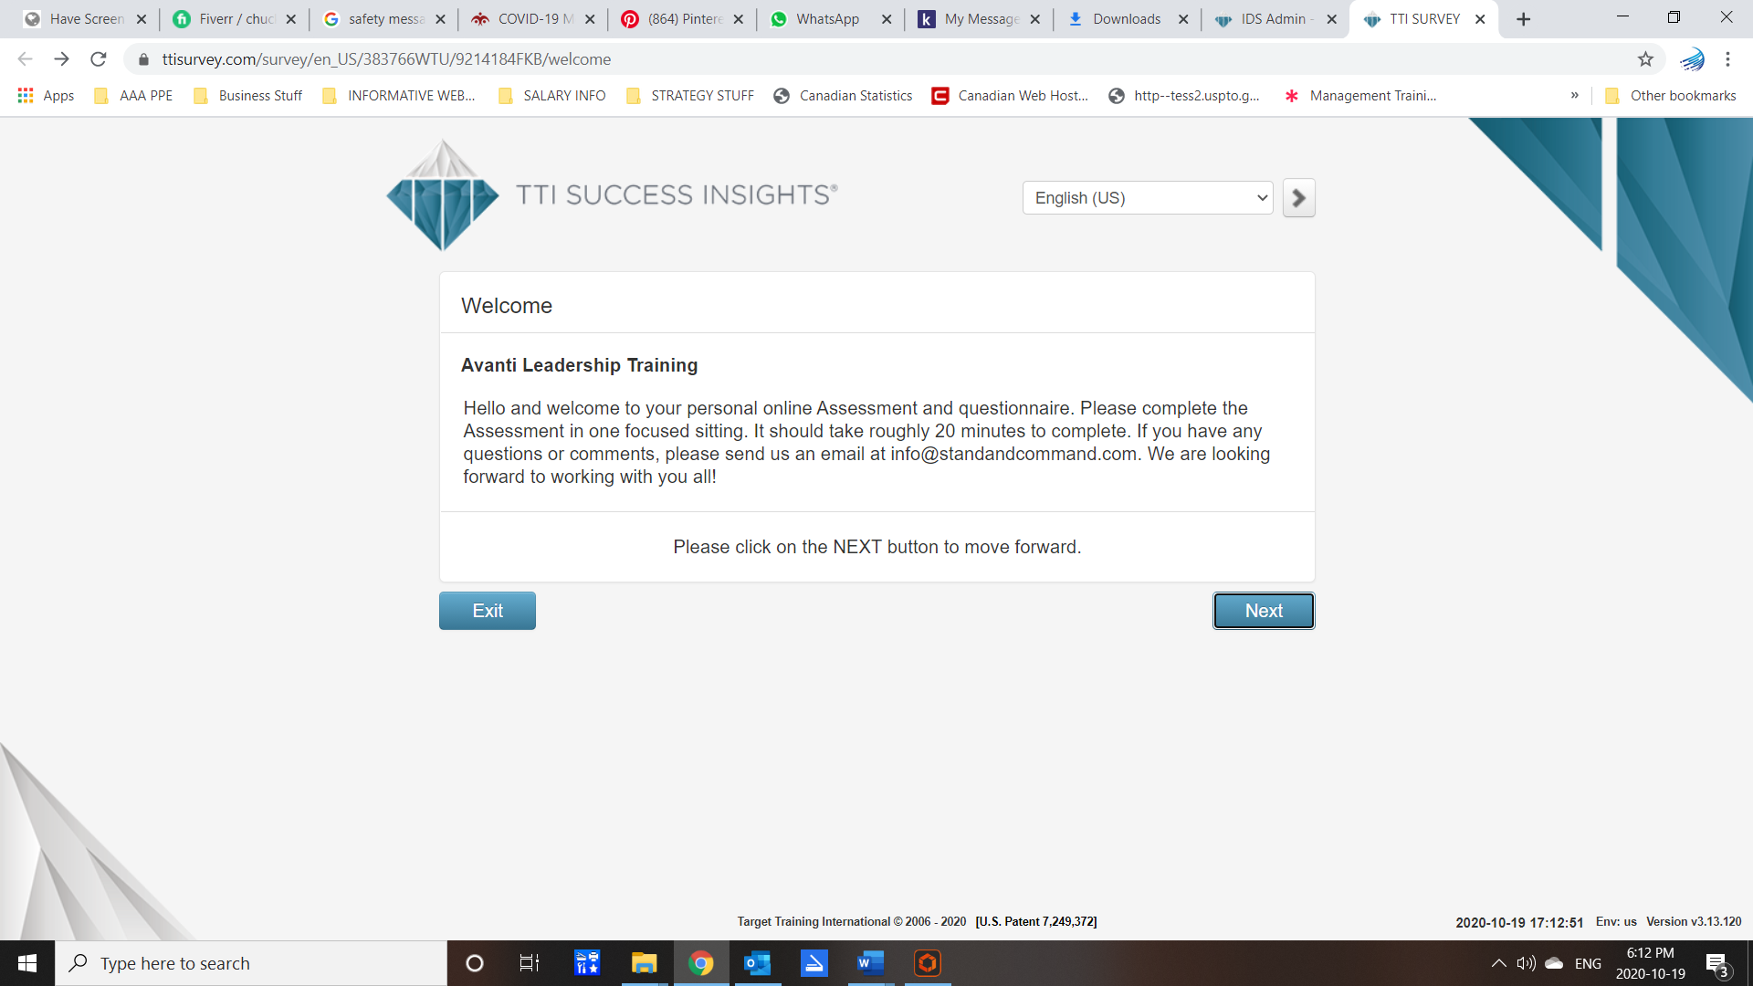

User then enters the following:

* Rater name
* Subject name
* Rater email address
* Rater Job position
  + Dropdown
    - Executive
    - Management
    - Staff
* Subject job position
  + Dropdown
    - Executive  
      Management  
      Staff
* Subject pronoun choice
  + Male
  + Female

On this login page, the user would be asked to read and confirm these statements:

**Data Use Consent**

By checking the box below, you give consent for The Method Effect to process the personal data you entered, including but not limited to your ethnicity (if entered), in connection with your completion of this assessment. By completing this assessment, you expressly agree that The Method Effect may evaluate your personal data and use the results to create various reports, including a personalized profile report about you, which will be released only to the company or agency that requested you to complete the assessment. Should you later decide that you do not want your personal data to be used, contact the company or agency that requested you to complete the assessment and your personal data will be erased within a period of 30 days.

Check here to give consent to use your personal data*

**Liability Waiver**

In consideration of being permitted to take the assessment, you hereby release The Method Effect, their agents, distributors, officers, employees, representatives, related or affiliated companies, and successors from all liability, and any actions or causes of action of every kind, nature, and description arising out of, or incidental to your taking the assessment, relating to the use of the assessment by the company or agency that requested you to complete the assessment. The Method Effect is not liable for any decisions made by the company or agency that requested you to complete the assessment. Information in the report(s) should not be used as the sole basis for consideration of selection for employment or job position.

Please check here that you have read and understood the agreement above*

Your privacy is important to us and we are committed and continue to meet the following programs’ strict requirements: EU-US Privacy Shield, Swiss-US Privacy Shield and GDPR. For more information, see our privacy statement: [TTI Privacy Statement](https://www.ttisurvey.com/privacy/en_US?expid=383766WTU&respid=9214184FKB)<link to privacy statement supplied>

Next

Next page with descriptor about the questionnaire stating this information:

This program has been developed after decades of observing workplace behaviors and applying them along side common phycological profiles and care practices. It has been designed to provide people managers to understand an employee’s strategic value to an organization and likely training needs and requirements.

You are asked to read each statement and rate the subject on a sliding scale. Once completed, you will receive a report either directly or from the program administrator. If you have any questions, please contact your program administrator. Thank you from The Method Effect.

Next the questionnaire starts